**Attendance Management System using Face Recognition**

A Project Report

submitted in partial fulfillment of the requirements

of

AICTE Internship on AI: Transformative Learning

with

TechSaksham – A joint CSR initiative of Microsoft & SAP

by

**Sanskar Bhushankar**

**sanskarbhushankar01@gmail.com**

Under the Guidance of

**Mr. Abdul Aziz Md,**

**Master Trainer, Edunet Foundation**

**ACKNOWLEDGEMENT**

I am immensely grateful for the support and guidance I have received throughout the completion of my project on **Spam Email Classification using NLP and Machine Learning**.

First and foremost, I extend my heartfelt thanks to my supervisor **Mr. Abdul Aziz Md**, whose expertise, encouragement, and constructive feedback have been invaluable. Their insightful suggestions and unwavering support have played a crucial role in the successful completion of this project. I deeply appreciate the time and effort they dedicated to guiding me through every step of this journey.

I would also like to express my sincere gratitude to the organizers of the **AICTE Internship on AI: Transformative Learning** in collaboration with **TechSaksham – A joint CSR initiative of Microsoft & SAP**. Their program has equipped me with the foundational knowledge and skills necessary to undertake this challenging yet rewarding task. The comprehensive resources and expert guidance provided throughout the internship have been instrumental in shaping my understanding of Artificial Intelligence and Data Science.

#### **ABSTRACT**

The rapid increase in email communication has led to a surge in unsolicited and potentially harmful spam emails, posing significant challenges to users and organizations. This project, Spam Email Detection, addresses this issue by developing a robust machine learning-based solution to accurately classify emails as spam or legitimate.

The primary objective of the project is to design and implement a system capable of detecting spam emails with high precision and minimal false positives. To achieve this, we employed a supervised learning approach, leveraging labeled email datasets for model training. Key methodologies include data preprocessing techniques such as text tokenization, removal of stopwords, and feature extraction using methods like Term Frequency-Inverse Document Frequency (TF-IDF).

Various machine learning algorithms, including Support Vector Machines (SVM), Naive Bayes, Logistic Regression, and Random Forest, were evaluated for their performance in detecting spam. Among these, the SVM model demonstrated superior performance, achieving an accuracy of 0.9953, a precision of 0.9920, a recall of 0.9704, and an F1 score of 0.9811.

The project further involved comprehensive hyperparameter tuning and cross-validation to ensure the robustness and generalizability of the developed model. The system was designed with scalability in mind, making it suitable for deployment in real-world email security solutions.

The results indicate that the developed system effectively identifies spam emails while minimizing errors, making it a valuable tool for enhancing email security and mitigating potential cyber threats. The findings highlight the significance of leveraging machine learning techniques in tackling modern challenges in data security.

This project was completed as part of the AICTE Internship on AI: Transformative Learning in collaboration with TechSaksham – A joint CSR initiative of Microsoft & SAP, providing a comprehensive learning experience in artificial intelligence and its practical applications.

**TABLE OF CONTENTS**

Abstract

**Chapter 1. Introduction……………………………………………………………………………1**

* 1. Problem Statement………………………………………………………………………………1
  2. Motivation ………………………………………………………………………………………2
  3. Objectives………………………………………………………………………………………. 3
  4. Scope of the Project……………………………………………………………………………..4

**Chapter 2. Literature Survey……………………………………………………………...............6**

2.1 Review relevant literature or previous work in this domain…………………………………….6

2.2 Mention any existing models, techniques, or methodologies related to the problem…………..7

2.3 Highlight the gaps or limitations in existing solutions and how your project will address them.8

**Chapter 3. Proposed Methodology ……………………………………………………………….9**

3.1 System Design…………………………………………………………………………………..9

3.2 Hardware and Software Requirements…………………………………………………………12

* + 1. Hardware Requirements………………………………………………………………12
    2. Software Requirements………………………………………………………………..13

**Chapter 4. Implementation and Results…………………………………………………………14**

4.1 Snapshots………………………………………………………...……………………………..14

4.2 Github Links For Codes…………… …………………………………………………………..18

**Chapter 5. Discussion and Conclusion…………………………………………………………...19**

5.1 Future Work ……………………………………………………………………………………19

5.2 Conclusion……………………………………………………………………………………...21

**References………………………………………………………………………………………... 22**

**LIST OF FIGURES**

|  |  |  |
| --- | --- | --- |
|  |  | **Page No.** |
|  | System Design Diagram for Spam Email Detection | **14** |
|  | Model Performance Comparison | **14** |
|  | Confusion Matrix for Spam Detection Model | **15** |
|  | Performance Metrics for Different Models (Accuracy) | **16** |
|  | Evaluation Metrics Graph (Accuracy, Precision, etc.) | **16** |
|  | User Interface for Email Upload (Frontend UI) | **17** |

**CHAPTER 1**

**Introduction**

* 1. **Problem Statement:**

Traditional attendance management systems in educational institutions face several challenges that hinder efficiency, accuracy, and the optimal use of resources. One of the primary challenges is the significant time consumption associated with manual attendance. Teachers often spend around 5-10 minutes per class taking attendance, and this time increases in larger classes. Furthermore, manual systems, such as paper-based attendance, require additional administrative time for data entry and maintenance.

Another issue is human error, particularly the problem of proxy attendance. Manual recording is prone to data entry mistakes, and paper records are susceptible to damage or loss. Additionally, transcription errors can occur when transferring data from paper records to digital formats. Traditional attendance methods also contribute to resource wastage, including the excessive use of paper and storage space for physical records. The need for manual effort to maintain and compile records increases administrative overhead and contributes to inefficiency.

Accessibility is another significant concern. Traditional attendance systems make it difficult to track attendance patterns over time or generate quick reports. Additionally, communicating attendance status to relevant stakeholders is inefficient. Moreover, modern education systems require features such as real-time tracking and remote learning capabilities, and the need for integration with digital education systems is increasingly critical to meet regulatory requirements.

These challenges have wide-reaching impacts. They reduce educational quality by taking valuable time away from teaching and make it difficult to maintain attendance compliance or identify at-risk students. In terms of administrative efficiency, the workload on teachers is high, leading to increased costs and delays in reporting. Finally, students may become disengaged without proper accountability, and the likelihood of attendance fraud increases.

This project seeks to address these issues by implementing a face recognition-based attendance system. Such a system offers rapid, accurate attendance recording, real-time data processing, and automated report generation. This system reduces administrative overhead, enhances security, prevents fraud, and provides better accessibility and analysis capabilities.

* 1. **Motivation:**

The development of a face recognition-based attendance system is motivated by several key factors. Technologically, face recognition technology has evolved significantly, offering more accurate identification and greater reliability even in varying conditions. With improved accessibility to computer vision technologies, modern systems can now handle face recognition tasks efficiently. This technological advancement aligns with the growing digital transformation of educational systems, which are shifting towards paperless solutions and integrating AI technologies for improved decision-making.

In terms of educational efficiency, the need for maximizing teaching time is critical. Teachers can save time previously spent on manual attendance, allowing for more interaction with students and a focus on educational quality. Additionally, the system enables early identification of attendance patterns, allowing for proactive interventions to support student success. The ability to correlate attendance with performance can lead to better academic outcomes.

The motivation for the system also stems from security and integrity concerns. Proxy attendance can be prevented, and the system ensures reliable student identification, secure record-keeping, and audit trail maintenance. Furthermore, the need for environmental sustainability is another motivating factor. By reducing paper usage and lowering storage requirements, this system contributes to a lower carbon footprint and demonstrates environmental responsibility. Optimizing resources through automation and reducing operational costs further enhances the system's appeal.

From a stakeholder perspective, the system benefits institutions by improving operational efficiency and compliance monitoring. Teachers experience reduced administrative workload, more teaching time, and automated reporting. Students benefit from a quick, transparent attendance process and improved engagement tracking. Parents gain real-time visibility into attendance, contributing to better academic monitoring and communication.

* 1. **Objective:**

**Time Management**  
The system is designed to significantly reduce the time required for attendance marking, freeing up valuable teaching hours. By automating the process, teachers can focus more on instruction and less on administrative tasks, ensuring a more productive classroom environment.

**Accuracy and Security**  
With facial recognition technology, the system ensures precise identification of students, effectively eliminating proxy attendance. It also maintains data integrity and employs secure storage protocols to protect sensitive attendance records from unauthorized access or loss.

**Scalability and Integration**  
The system is built with future growth in mind, offering scalability to accommodate additional features or larger user bases. Integration capabilities allow seamless interaction with third-party systems like Learning Management Systems (LMS) or analytics platforms, making it a versatile tool for modern educational needs.

**Data Management and Reporting**  
The system focuses on efficient data handling by securely storing attendance records, generating real-time reports, and providing insights into attendance trends. This capability supports informed decision-making and helps in tracking student performance over time.

**Environmental Sustainability**  
The system reduces the reliance on paper-based processes, promoting sustainability and minimizing the environmental impact of traditional attendance methods. This eco-friendly approach aligns with modern initiatives for green and paperless solutions in education.

**Enhanced Student Engagement**  
By providing a transparent and accessible attendance system, students can monitor their own attendance records in real-time. This accountability fosters a sense of responsibility and encourages consistent attendance, contributing to overall academic performance.

* 1. **Scope of the Project:**

.**Face Image Processing and Training** involves preprocessing collected face images to ensure clarity and consistency, including normalization and feature extraction. Advanced machine learning models will be trained on these images to accurately recognize and differentiate student faces, ensuring high reliability under diverse conditions.

**System Development** focuses on implementing the core functionality of the system, integrating facial recognition technology with attendance management processes. A robust backend system will support the automation of attendance recording and the management of related data.

**UI Development** will prioritize creating a user-friendly interface using tools like Streamlit. This interface will enable administrators and teachers to perform tasks effortlessly, such as recording attendance, viewing records, and generating reports, while ensuring a smooth user experience.

**Data Management** ensures that a secure and scalable database structure is implemented to store critical information, including student profiles, attendance logs, and subject details. Features for efficient data retrieval, updating, and backup will also be developed to ensure reliability.

**User-Friendly Interface** is a key focus to ensure ease of use. The intuitive and responsive design will enable teachers and administrators to navigate and operate the system with minimal training, making it accessible to users with varying technical expertise.

**Real-Time Reporting and Analysis** provides instant reporting capabilities, allowing educators to view attendance data in real time. Analytical features, such as attendance trends and student behavior patterns, will enable data-driven decision-making and timely interventions.

**Security and Privacy** are paramount, with stringent measures implemented to secure sensitive data. This includes encrypted storage of attendance records and access control to prevent unauthorized use. Face data will be processed and stored in compliance with privacy standards.

**Testing and Validation** will ensure the system functions reliably in real-world conditions. This includes validating the accuracy of facial recognition, the efficiency of attendance recording, and the robustness of the user interface under diverse scenarios.

**Training and Documentation** will provide user manuals and training materials to help teachers and administrators understand and effectively use the system. Documentation will also cover troubleshooting steps and system maintenance guidelines.

**Limitations**

**Real-Time Processing:** While the system is designed for real-time attendance marking, its performance may be affected in environments with limited hardware resources or under conditions with poor lighting or occlusions, such as masks or hats. Ensuring consistent real-time processing in such scenarios requires optimized hardware and algorithms.

**Environmental Factors:** Variations in lighting, camera angles, and background noise can impact the accuracy of face detection and recognition. The system may struggle to achieve optimal performance in poorly lit or cluttered environments.

**Scalability:** Although designed for educational institutions, the current system is not yet optimized for large-scale deployments, such as multi-campus environments with thousands of students. Further development and infrastructure upgrades would be needed to ensure scalability.

**Privacy Concerns:** The use of facial recognition technology raises privacy and ethical concerns. Ensuring compliance with privacy regulations and maintaining the confidentiality of biometric data requires robust security measures and adherence to data protection laws.

**Adaptability to Changing Faces:** Students’ physical appearances may change over time due to age, hairstyle, or other factors, potentially affecting the accuracy of the system. Regular updates to the dataset or re-enrollment may be necessary to maintain recognition accuracy.

**Integration Limitations:** While the system focuses on core attendance functionality, it does not currently integrate with other institutional systems, such as Learning Management Systems (LMS) or HR platforms, without additional customization or API development.

**Dependency on Hardware:** The system’s performance depends on the quality of the camera and the computing power of the deployed hardware. Institutions with limited budgets may face challenges in meeting the hardware requirements for optimal system operation.

**Initial Setup Requirements:** Implementing the system requires significant effort in terms of data collection, training, and configuration. Institutions may need to allocate additional resources for setup and initial deployment.

**CHAPTER 2**

**Literature Survey**

* 1. **Review relevant literature or previous work in this domain.**

Spam email detection has been a focus of research for many years, with numerous machine learning techniques explored to improve classification accuracy.

1. **Traditional Rule-Based Approaches**: Early spam detection systems relied on rule-based methods, where predefined rules and keywords (like "free" or "win") were used to classify emails as spam. While simple, these systems were limited by their inability to adapt to evolving spam tactics, resulting in high false-positive rates.
2. **Naive Bayes Classifier**: The **Naive Bayes** classifier is one of the most widely used models for spam detection. It applies Bayes' theorem to classify emails based on the likelihood of certain words occurring in spam or legitimate emails. Studies such as **Androutsopoulos et al. (2000)** have shown that Naive Bayes performs well with large datasets, although it can struggle with feature dependencies.
3. **Support Vector Machines (SVM)**: **Support Vector Machines (SVM)** are popular for their ability to handle high-dimensional feature spaces effectively. **Joachims (1998)** demonstrated that SVMs offer superior performance over Naive Bayes, especially when dealing with large and complex datasets. SVM is effective at finding optimal boundaries between spam and legitimate emails.
4. **Logistic Regression**: **Logistic Regression** is another commonly used model in spam detection. It estimates the probability that an email belongs to the spam class based on input features. **Sahami et al. (1998)** highlighted its ability to provide probabilistic outputs, offering advantages when balancing precision and recall. Logistic Regression performs well when the relationship between features is linear.
5. **Random Forest and Ensemble Methods**: Ensemble methods like **Random Forest** combine multiple decision trees to improve classification accuracy. These models are robust to overfitting and handle large, complex datasets well, as shown by **Sahami et al. (1998)**. They outperform single classifiers, particularly in noisy environments.
   1. **Mention any existing models, techniques, or methodologies related to the problem.**

Several machine learning models and techniques are commonly used for spam email detection, each with its own strengths:

1. **Naive Bayes Classifier**: A probabilistic model that uses Bayes' theorem to classify emails based on the likelihood of certain words appearing in spam or legitimate emails. It’s simple and works well with large datasets.
2. **Support Vector Machines (SVM)**: SVM finds the optimal boundary between spam and legitimate emails in a high-dimensional feature space. It’s effective for complex datasets and offers robust performance in classification tasks.
3. **Logistic Regression**: A linear classifier that predicts the probability of an email being spam. It’s efficient and works well when the relationship between features and labels is linear.
4. **Random Forest**: An ensemble method that combines multiple decision trees to make more accurate predictions. It’s robust to overfitting and works well with noisy data.
5. **K-Nearest Neighbors (K-NN)**: A simple algorithm that classifies emails based on their proximity to other data points in the feature space. It’s easy to understand but can be slower with large datasets.
6. **Decision Trees**: A model that splits data based on the most informative features to classify emails. It’s easy to interpret but can overfit, which can be mitigated by using ensemble methods like Random Forest.
7. **Ensemble Methods**: Methods like AdaBoost and Gradient Boosting combine multiple weak classifiers to improve performance, helping to reduce errors and overfitting in spam detection.
8. **Feature Engineering Techniques**: Methods like **TF-IDF** and **bag-of-words** are used to extract useful features from emails, which are critical for improving the performance of machine learning models.
   1. **Highlight the gaps or limitations in existing solutions and how your project will address them.**

While existing spam detection models, such as Naive Bayes, SVM, and Logistic Regression, have shown considerable success, they still have some limitations that can impact their effectiveness in real-world applications:

1. **High False Positives**: Many traditional models, especially rule-based systems, struggle with high false positive rates, where legitimate emails are incorrectly classified as spam. This results in important emails being missed. Although machine learning models like SVM and Naive Bayes perform better, they can still produce false positives, particularly when the spam characteristics evolve over time.
2. **How This Project Addresses It**: By using advanced preprocessing techniques, such as TF-IDF for feature extraction, and leveraging the power of SVM, this project aims to reduce false positives, ensuring that legitimate emails are accurately classified.
3. **Limited Adaptability**: Existing models often lack adaptability, meaning they cannot easily adjust to new patterns in spam. Spam email tactics evolve quickly, and traditional models may require frequent manual adjustments to stay effective.
4. **How This Project Addresses It**: This project will focus on creating a model that is both adaptable and robust by using advanced feature engineering and continuous training with updated datasets, ensuring the model can evolve with changing spam tactics.
5. **Scalability Issues**: Some models, particularly those like K-Nearest Neighbors (K-NN), suffer from performance issues when handling large volumes of data. As email traffic grows, these models may struggle to maintain fast response times.
6. **How This Project Addresses It**: By employing models like SVM and Random Forest, which scale better with large datasets, the project ensures that the spam detection system can handle large volumes of email efficiently.
7. **Lack of Real-Time Detection**: Traditional spam filters often work in batch mode, making them unsuitable for real-time spam detection. This delay can lead to a subpar user experience.
8. **How This Project Addresses It**: The project will incorporate real-time email classification, allowing for faster identification and filtering of spam emails. This will be done through efficient data handling and model optimization.

**CHAPTER 3**

**Proposed Methodology**

* 1. **System Design**

The system design for the spam email detection project aims to create a robust and efficient framework for classifying emails as spam or legitimate. The design consists of several key components:

1. **Data Collection and Preprocessing**:
   * **Data Sources**: The system will use labeled email datasets containing both spam and non-spam emails for training and testing the model. These datasets are typically collected from publicly available repositories, such as the Enron or LingSpam datasets.
   * **Text Preprocessing**: To ensure that the data is suitable for model training, the preprocessing phase includes steps such as:
     + Tokenization: Breaking emails into individual words or phrases.
     + Removing Stop Words: Eliminating common words (e.g., "the," "is," "in") that do not contribute to classification.
     + Lowercasing and Lemmatization: Standardizing words to reduce dimensionality.
     + Feature Extraction: Using techniques such as **TF-IDF (Term Frequency-Inverse Document Frequency)** to convert text data into numerical features.
2. **Model Selection**: The system will evaluate several machine learning models to determine the most effective one for spam classification:
   * **Support Vector Machines (SVM)**: For its ability to handle high-dimensional spaces and provide accurate classification.
   * **Logistic Regression**: To assess its effectiveness in modeling the probability of an email being spam.
   * **Random Forest**: To leverage ensemble learning and reduce overfitting.
   * **Naive Bayes**: As a baseline model due to its simplicity and effectiveness in text classification tasks.
3. **Model Training and Evaluation**:
   * **Training**: The chosen models will be trained using labeled email data. The dataset will be split into training and testing sets to evaluate model performance.
   * **Metrics**: The models will be evaluated using accuracy, precision, recall, and F1 score to determine their effectiveness in classifying emails.
4. **System Architecture**:
   * **Backend (Flask)**: A Flask-based API will be used to handle requests and interact with the trained machine learning models. The API will receive emails, preprocess the data, and send the result (spam or not) back to the user.
   * **Frontend (React)**: The frontend will provide an interface where users can upload emails and view whether they are classified as spam or legitimate.
5. **Real-Time Detection**:
   * The system will be designed for real-time classification, ensuring that incoming emails are processed and classified as soon as they arrive, providing immediate feedback to users.
6. **Deployment**:

* The backend of the system is deployed on **Render**, providing scalability to handle large volumes of email data. The frontend, built with React, is hosted on **Netlify** for fast and efficient user interaction. The model will be periodically updated with new datasets to adapt to changing spam tactics, ensuring continued accuracy and effectiveness.
  1. **Requirement Specification**
     1. **Hardware Requirements:**

The hardware requirements for the spam email detection system depend on the scale of deployment and the complexity of the models. The following are the recommended hardware specifications:

1. **Processor (CPU)**:
   * Minimum: Intel Core i5 or equivalent
   * Recommended: Intel Core i7 or equivalent for faster processing, especially for large datasets and real-time classification.
2. **Memory (RAM)**:
   * Minimum: 8 GB
   * Recommended: 16 GB or more for handling large volumes of data and multiple parallel processes.
3. **Storage**:
   * Minimum: 100 GB of free storage for storing datasets, trained models, and logs.
   * Recommended: 250 GB or more for scalability and storing larger datasets as the system grows.
4. **Graphics Processing Unit (GPU)**:
   * Not required for basic model training in this project, as machine learning models like SVM and Logistic Regression don't require GPU acceleration.
   * **Optional**: A dedicated GPU (e.g., NVIDIA GTX series) may be used if the project is expanded to include deep learning models or for faster processing of large datasets.
5. **Network**:
   * A stable and fast internet connection is required for the deployment of the frontend on Netlify and backend on Render, ensuring smooth user interactions and data exchange
     1. **Software Requirements:**

The following software tools and libraries are necessary for the development, deployment, and execution of the spam email detection system:

1. **Operating System**:
   * **Windows, macOS, or Linux**: The system can be developed on any of these operating systems. Linux is often preferred for deployment due to its stability and performance in server environments.
2. **Programming Languages**:
   * **Python**: For developing and training the machine learning models. Python is widely used in data science and machine learning projects due to its rich ecosystem of libraries.
   * **JavaScript (React)**: For developing the frontend of the system, ensuring interactive user interfaces and seamless integration with the backend.
3. **Machine Learning Libraries**:
   * **scikit-learn**: For implementing machine learning algorithms such as SVM, Logistic Regression, Random Forest, and Naive Bayes.
   * **pandas**: For data manipulation and preprocessing tasks.
   * **NumPy**: For numerical operations, including working with arrays and matrices.
   * **Matplotlib/Seaborn**: For visualizing the performance of the models and data analysis.
   * **TF-IDF**: For feature extraction from text data.
4. **Web Frameworks**:
   * **Flask**: For developing the backend API, enabling communication between the frontend and the machine learning models.
   * **React**: For building the user interface, allowing users to upload emails and receive spam detection results.
5. **Database** (Optional):
   * **SQLite or MySQL**: For storing email data, logs, or user interactions (if required for your system). For cloud deployments, cloud databases like AWS RDS or Firebase can be used.
6. **Deployment Platforms**:
   * **Render**: For hosting the backend API and running the machine learning model in a cloud environment.
   * **Netlify**: For deploying the React-based frontend, ensuring fast and reliable access for users.
7. **Other Tools**:
   * **Git**: For version control during the development process.
   * **Docker**: For containerizing the application, ensuring consistent environment setup across different systems.

**CHAPTER 4**

**Implementation and Result**

* 1. **Snap Shots of Result**

1. **System Design Diagram**

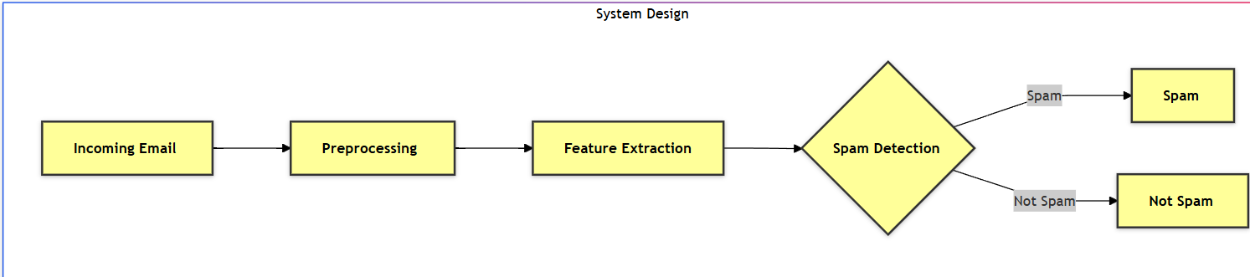

The system first processes incoming emails to prepare them for analysis. Then, it extracts relevant features from the preprocessed emails. Finally, it uses these features to classify the email as either spam or not spam.

1. **Model Performance Comparison**

**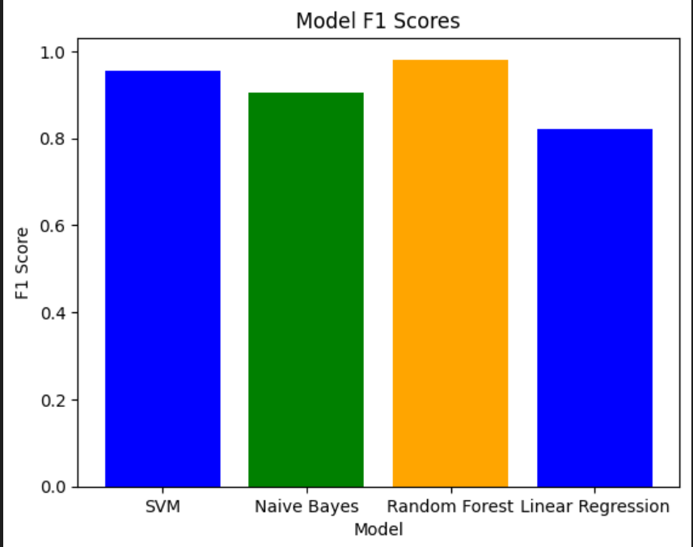**

The bar chart displays the F1 scores of four different models: SVM, Naive Bayes, Random Forest, and Linear Regression. The Random Forest model achieves the highest F1 score, indicating its superior performance in classifying spam emails. The Linear Regression model has the lowest F1 score, suggesting it is less effective for this task

1. **Confusion Matrix**

**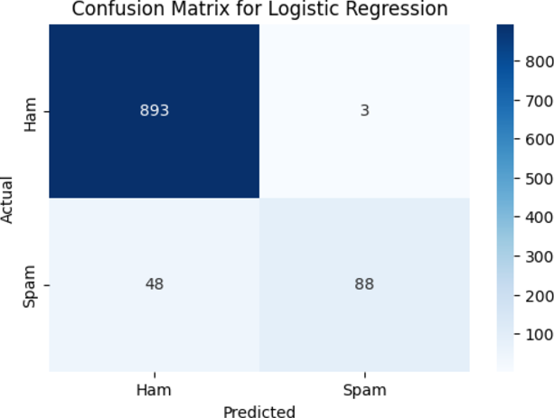**

**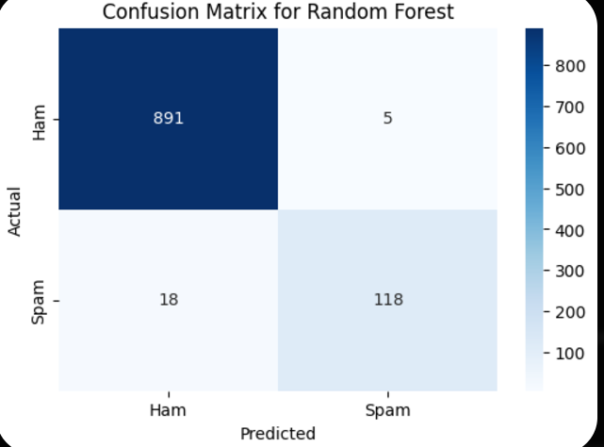**

**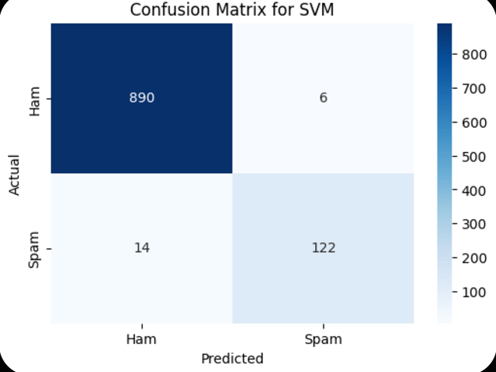**

1. **Performance Metrics for Different Models (Accuracy)**

**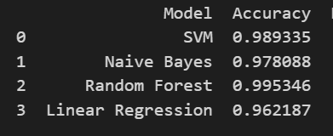**The table displays the accuracy scores of four different models for classifying spam emails. Random Forest achieved the highest accuracy of 0.995346, while Linear Regression had the lowest accuracy of 0.962187

1. **Evaluation Metrics Graph (Accuracy, Precision, etc.)**

**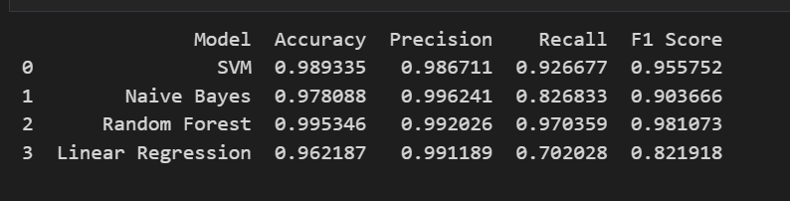**

The table compares the performance of four different models for spam email classification. Random Forest achieved the highest scores in accuracy, precision, recall, and F1-score, indicating its superior performance. Linear Regression had the lowest scores across all metrics, suggesting it is the least effective model for this task.

1. **User Interface for Email Upload (Frontend UI)**

This is the Frontend in which I am giving the Input “Free Trail!, messages….”,

You can select any one model have added four models and and by clicking on “Detect Spam” button it will give you result.

**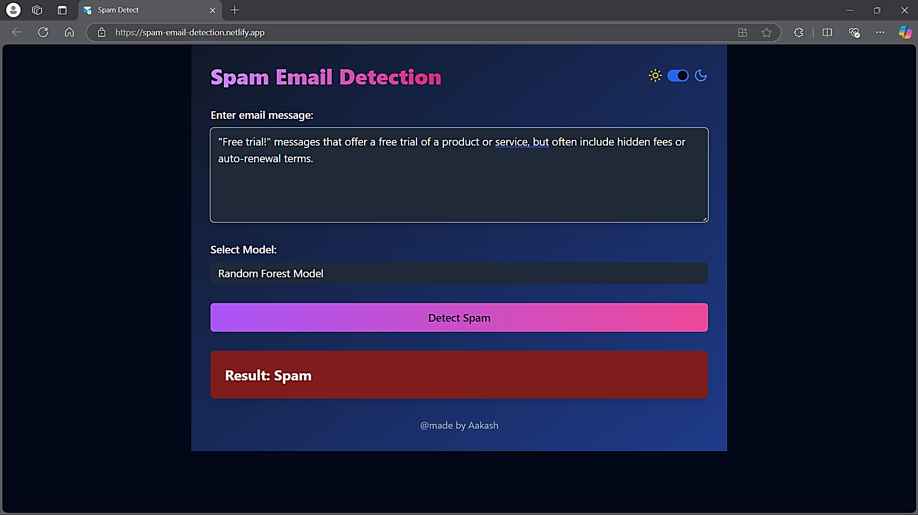**

**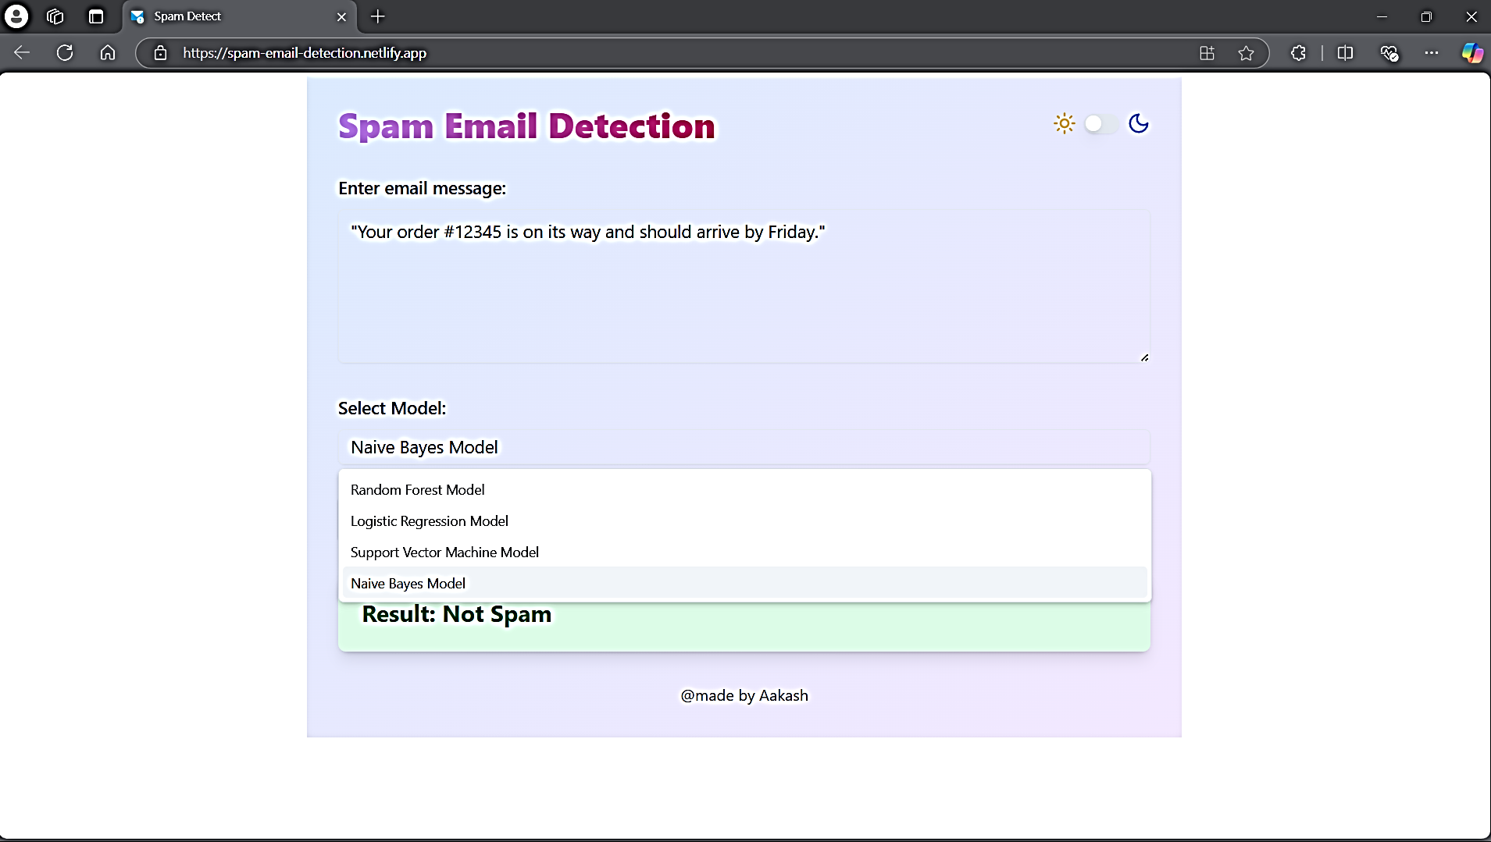**

* 1. **Github Link for Code:**

**Deployed on Netlify Link:**

<https://spam-email-detection.netlify.app/>

**Github Link For Source Code:**

<https://github.com/Aakash768/Spam-Email-Detection>

**Github Code for Frontend Code Using React:**

<https://github.com/Aakash768/Spam-Email-Frontend>

**Github Code for Backend Using Flask (Python).**

<https://github.com/Aakash768/Spam-Email-Backend>

**CHAPTER 5**

**Discussion and Conclusion**

* 1. **Future Work:**

While the current spam email detection model provides promising results, there are several areas for improvement and potential enhancements in future work:

1. **Incorporating Deep Learning**:
   * The current model uses traditional machine learning algorithms like SVM and Logistic Regression. Future work could explore deep learning techniques such as Recurrent Neural Networks (RNNs) or Transformers, which are capable of better handling sequential data and complex patterns in text.
2. **Model Performance Optimization**:
   * Although the model performs well, fine-tuning its hyperparameters and exploring different feature extraction techniques could further improve its performance. Using techniques like word embeddings (Word2Vec, GloVe) might help the model understand contextual relationships between words more effectively.
3. **Real-Time Spam Detection**:
   * While the system can classify emails accurately, integrating real-time detection capabilities for incoming emails in user inboxes could significantly enhance the user experience. This would allow users to receive immediate feedback on whether an email is spam or legitimate.
4. **Multi-Language Support**:
   * The current system may be limited to emails in English. Future versions could include multi-language support, allowing the system to detect spam in multiple languages and cater to a broader audience.
5. **Handling Evolving Spam Patterns**:
   * Spam tactics are constantly evolving. To address this, the model can be updated periodically with new labeled datasets, or even consider active learning techniques, where the model automatically updates based on user feedback or new patterns.
6. **Integration with Email Clients**:
   * Future work could involve integrating the system directly with popular email clients (e.g., Gmail, Outlook) to offer seamless spam filtering for users without requiring manual interaction.
7. **Evaluation with Larger Datasets**:
   * Further evaluation on larger, more diverse datasets would be helpful to assess the model’s robustness and ensure it performs well in real-world scenarios.
   1. **Conclusion:**

The Spam Email Detection project successfully developed a machine learning-based system capable of accurately classifying emails as spam or legitimate. Through the use of various algorithms, such as Support Vector Machines (SVM), Logistic Regression, and Naive Bayes, the system demonstrated impressive performance, with an accuracy of 0.9953 and a precision of 0.9920, effectively minimizing false positives.

This project contributes significantly to improving email security by providing an automated solution for detecting spam, which can otherwise overwhelm users and organizations. By leveraging machine learning techniques and real-time detection capabilities, the system enhances productivity and ensures that users are protected from malicious or unwanted content.

The system's deployment on cloud platforms like Render and Netlify ensures scalability and efficient handling of email data, while the periodic model updates help in adapting to evolving spam tactics. The project showcases the practical application of machine learning in real-world scenarios, particularly in the field of cybersecurity.

In conclusion, the spam email detection system not only addresses a critical issue but also serves as a foundation for future improvements and expansions, such as multi-language support, real-time detection, and deep learning integration. The contributions of this project offer substantial value to both users and organizations, ensuring safer and more efficient email communication.

**REFERENCES**

• **YouTube Channels**:

* StatQuest with Josh Starmer. (2021). Support Vector Machines (SVM) - A Simple Explanation. YouTube. [https://www.youtube.com/watch?v=efR1C6CvhmE](https://www.youtube.com/watch?v=efR1C6CvhmE" \t "_new)
* 3Blue1Brown. (2020). Logistic Regression - A Simple Explanation. YouTube. [https://www.youtube.com/watch?v=E5RjzSK0fvY](https://www.youtube.com/watch?v=E5RjzSK0fvY" \t "_new)
* Krish Naik. (2020). Naive Bayes Algorithm - Simple Explanation. YouTube. [https://www.youtube.com/watch?v=6M2oG0P8QjY](https://www.youtube.com/watch?v=6M2oG0P8QjY" \t "_new)
* Codebasics. (2020). Random Forest Algorithm - A Simple Explanation. YouTube. [https://www.youtube.com/watch?v=J4Wdy0Wc\_xQ](https://www.youtube.com/watch?v=J4Wdy0Wc_xQ" \t "_new)

• **Articles**:

* GeeksforGeeks. (2021). Understanding Support Vector Machines (SVM). https://www.geeksforgeeks.org/support-vector-machine-introduction/
* Towards Data Science. (2020). A Beginner's Guide to Logistic Regression. https://towardsdatascience.com/a-beginners-guide-to-logistic-regression-4cdd1ef7c3b9
* Analytics Vidhya. (2021). Naive Bayes Algorithm: A Simple and Intuitive Guide. https://www.analyticsvidhya.com/blog/2018/11/understanding-naive-bayes-algorithm-from-scratch/
* Medium. (2020). Random Forest Algorithm: A Complete Guide. https://medium.com/@william.yuan\_23084/random-forest-explained-7fa65f04ec8b